Joining Tables
To get hands-on practice, we highly recommend you apply these concepts on DataLemur. The platform offers interactive, real-world SQL problems that will solidify your understanding.

SQL joins are used to combine rows from multiple tables based on a related column. They leverage the foreign key relationships we discussed earlier to create meaningful connections between data stored across different tables.Think of joins as a way to "reconstruct" related information that has been normalized across multiple tables. For example, if customer information is in one table and order information is in another, joins allow you to see customer details alongside their orders.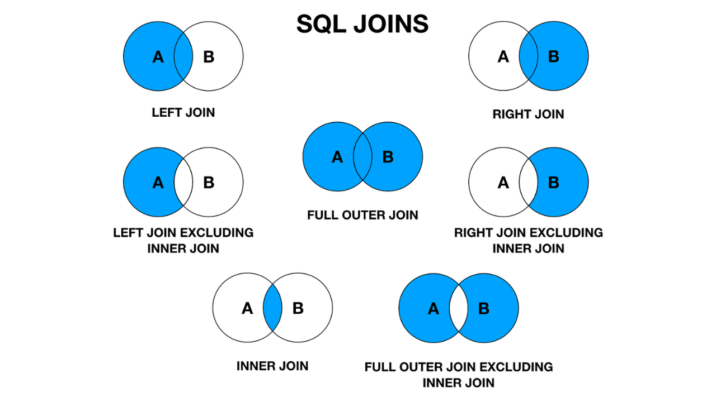

Types of Joins

1. INNER JOIN
An INNER JOIN returns only the rows that have matching values in both tables. This is the most restrictive type of join.
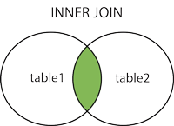
Syntax:
SELECT columns
FROM table1
INNER JOIN table2 ON table1.column = table2.column;

Example: Let's say we have these tables:
-- Customers table
CREATE TABLE customers (
customer_id SERIAL PRIMARY KEY,
name VARCHAR(100),
email VARCHAR(100)
);
-- Orders table
CREATE TABLE orders (
order_id SERIAL PRIMARY KEY,
customer_id INTEGER REFERENCES customers(customer_id),
order_date DATE,
total_amount DECIMAL(10,2)
);

INNER JOIN Query:
SELECT c.name, c.email, o.order_date, o.total_amount
FROM customers c
INNER JOIN orders o ON c.customer_id = o.customer_id;

This query returns only customers who have placed orders, along with their order details.

2. LEFT JOIN (LEFT OUTER JOIN)
A LEFT JOIN returns all rows from the left table and matching rows from the right table. If no match is found, NULL values are returned for the right table columns.
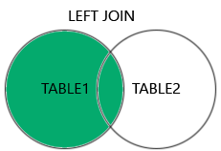
Syntax:
SELECT columns
FROM table1
LEFT JOIN table2 ON table1.column = table2.column;

Example:
SELECT c.name, c.email, o.order_date, o.total_amount
FROM customers c
LEFT JOIN orders o ON c.customer_id = o.customer_id;

This query returns all customers, including those who haven't placed any orders (their order columns will show NULL).

3. RIGHT JOIN (RIGHT OUTER JOIN)
A RIGHT JOIN returns all rows from the right table and matching rows from the left table. If no match is found, NULL values are returned for the left table columns.
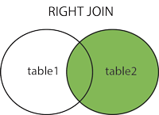
Syntax:
SELECT columns
FROM table1
RIGHT JOIN table2 ON table1.column = table2.column;

Example:
SELECT c.name, c.email, o.order_date, o.total_amount
FROM customers c
RIGHT JOIN orders o ON c.customer_id = o.customer_id;

This query returns all orders, even if the customer information is missing (customer columns would show NULL).

4. FULL OUTER JOIN

A FULL OUTER JOIN returns all rows when there's a match in either table. It combines the results of both LEFT and RIGHT joins.
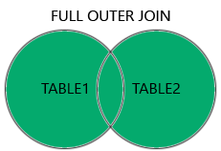
Syntax:
SELECT columns
FROM table1
FULL OUTER JOIN table2 ON table1.column = table2.column;

Example:
SELECT c.name, c.email, o.order_date, o.total_amount
FROM customers c
FULL OUTER JOIN orders o ON c.customer_id = o.customer_id;

This query returns all customers and all orders, with NULL values where there's no match.

5. CROSS JOIN
A CROSS JOIN returns the Cartesian product of both tables, meaning every row from the first table is combined with every row from the second table.
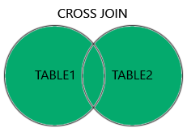

Syntax:
SELECT columns
FROM table1
CROSS JOIN table2;

Example:
SELECT c.name, p.product_name
FROM customers c
CROSS JOIN products p;

Warning: Use CROSS JOIN carefully as it can produce very large result sets!

Advanced Join Techniques

Multiple Table Joins
You can join more than two tables in a single query:
SELECT c.name, o.order_date, oi.quantity, p.product_name, p.price
FROM customers c
INNER JOIN orders o ON c.customer_id = o.customer_id
INNER JOIN order_items oi ON o.order_id = oi.order_id
INNER JOIN products p ON oi.product_id = p.product_id;

Self Joins
A table can be joined with itself to compare rows within the same table:
-- Find employees and their managers
SELECT e1.name AS employee, e2.name AS manager
FROM employees e1
LEFT JOIN employees e2 ON e1.manager_id = e2.employee_id;

Join with Conditions
You can add additional conditions to your JOIN clauses:
SELECT c.name, o.order_date, o.total_amount
FROM customers c
INNER JOIN orders o ON c.customer_id = o.customer_id
WHERE o.order_date >= '2024-01-01'
AND o.total_amount > 100;

Working with Different Relationship Types

One-to-One Relationships
For one-to-one relationships, INNER JOIN or LEFT JOIN are typically used:
-- Joining user profiles (one-to-one)
SELECT u.username, up.first_name, up.last_name, up.phone
FROM users u
LEFT JOIN user_profiles up ON u.user_id = up.user_id;

One-to-Many Relationships
For one-to-many relationships, be aware that the "one" side may be repeated:
-- Authors and their books (one-to-many)
SELECT a.author_name, b.title, b.publication_year
FROM authors a
INNER JOIN books b ON a.author_id = b.author_id
ORDER BY a.author_name, b.publication_year;

Many-to-Many Relationships
For many-to-many relationships, you'll need to join through the junction table:
-- Students and their enrolled courses (many-to-many)
SELECT s.student_name, c.course_name, e.enrollment_date, e.grade
FROM students s
INNER JOIN enrollments e ON s.student_id = e.student_id
INNER JOIN courses c ON e.course_id = c.course_id
WHERE e.grade IS NOT NULL
ORDER BY s.student_name, c.course_name;

Performance Considerations

Use Indexes
Ensure foreign key columns and join columns have indexes:
-- Create indexes on foreign key columns
CREATE INDEX idx_orders_customer_id ON orders(customer_id);
CREATE INDEX idx_order_items_order_id ON order_items(order_id);
CREATE INDEX idx_order_items_product_id ON order_items(product_id);

Choose the Right Join Type
- Use INNER JOIN when you only need matching records
- Use LEFT JOIN when you need all records from the left table
- Avoid CROSS JOIN unless you specifically need a Cartesian product

Table Aliases
Use table aliases to make queries more readable and potentially faster:
SELECT c.name, o.order_date
FROM customers c
INNER JOIN orders o ON c.customer_id = o.customer_id;

Common Pitfalls and How to Avoid Them

1. Cartesian Products
Problem: Forgetting the JOIN condition creates a Cartesian product. Solution: Always specify proper JOIN conditions.
-- Wrong (Cartesian product)
SELECT c.name, o.order_date
FROM customers c, orders o;
-- Correct
SELECT c.name, o.order_date
FROM customers c
INNER JOIN orders o ON c.customer_id = o.customer_id;

2. Null Value Confusion
Problem: Not understanding how NULLs work in outer joins. Solution: Use IS NULL or IS NOT NULL appropriately.
-- Find customers without orders
SELECT c.name
FROM customers c
LEFT JOIN orders o ON c.customer_id = o.customer_id
WHERE o.customer_id IS NULL;

3. Many-to-Many Join Errors
Problem: Forgetting to include the junction table. Solution: Always join through the junction table for many-to-many relationships.

